HTML, Widget, and Graphic Primitives Tutorial

HTML, or hypertext markup language, is an easy way to tell a webpage (or our touch panel) how the text and pictures on the screen should be displayed. For example, how large should the font be? Should the font be bold or italicized? Where should the pictures go on the screen?

We will be going through some examples. Open your favorite text editor (i.e. Notepad, Emacs, etc.) and save the file to your desktop as amulet.html.

This is what you should copy into your text editor in the amulet.html file.  Explanation:  Here, we explain the example. | This is what you should see when you open amulet.html in a web browser (i.e. Internet Explorer, Netscape)

1. HTML Tags

To specify appearance, HTML uses commands called tags, which are denoted between angle brackets (< and >). Typically there is a start tag and end tag to start and stop the command. For example:

Source code | What you see in a web browser
Hi! <b>This text is bold,</b> but this text isn’t.  Explanation:  Bold and “un-bold” are <b> and </b> | Hi! This text is bold, but this text isn’t.

For a full list of what HTML tags are supported, please see the Amulet documentation under HTML – What is Supported, and What is Not.

2. HTML Tables

Tables will be useful in aligning text, pictures, and widgets (see Section 3: Amulet Widgets) wherever you want them on the Amulet LCD panel. You can break up the screen into pieces of any size, and place your text, pictures, or widgets into any of these pieces. You must use tables for alignment. Remember, white space in your HTML document does not correspond to white space on the Amulet LCD!

Here is a summary of tags you will find very useful:
COMMAND | DESCRIPTION
<TABLE>, </TABLE> | Defines the beginning and end of a table
<TR>, </TR> | Defines the beginning and end of a table row
<TD>, </TD> | Defines the beginning and end of a cell, or table data
ATTRIBUTE | DESCRIPTION
WIDTH=“x” | Sets the width of the table or cell to x pixels
HEIGHT=“x” | Sets the height of the table or cell to x pixels
*BORDER=“x” | Sets the thickness of the border
ALIGN= “RIGHT”|“LEFT”|“CENTER” | Aligns content to the right, left, or center of the cell
VALIGN=“TOP”|“BOTTOM”|“CENTER” | Aligns content to the top, bottom, or center of the cell
ROWSPAN=“x” | Sets the current cell to take up x number of rows
COLSPAN=“x” | Sets the current cell to take up x number of columns
*The Amulet Compiler sets borders to zero – the border attribute is useful only for viewing the table edges in a web browser.

Source code | What you see in a web browser
<TABLE BORDER="1" WIDTH="320" HEIGHT="240">  <TR>  <TD WIDTH="320" HEIGHT="240">  Hi !  </TD>  </TR>  </TABLE>  Explanation:  This gives us a table with a single cell. The table is 320 pixels x 240 pixels (the resolution of the Amulet screen!). “Hi !” is written in the cell. Notice that only one space appears in your web browser between “Hi” and “!”. | 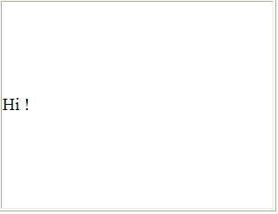
<TABLE BORDER="1" WIDTH="320" HEIGHT="240">  <TR>  <TD WIDTH="200" HEIGHT="80"> 1 </TD>  <TD WIDTH="120" HEIGHT="80"> 2 </TD>  </TR>  <TR>  <TD> 3 </TD>  <TD> 4 </TD>  </TR>  </TABLE>  Explanation:  Now we have four cells in our 240x320 table. We define the dimensions of the cells in the first row only. The widths of the second row cells are set by the dimensions of the first. The height of the second row is set to fill the rest of the table. | 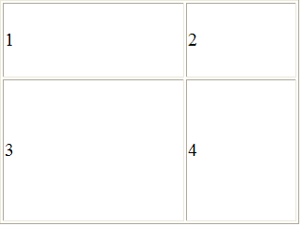
<TABLE BORDER="1" WIDTH="320" HEIGHT="240">  <TR>  <TD WIDTH="200" HEIGHT="80"> 1 </TD>  <TD WIDTH="120" HEIGHT="80">  <TABLE BORDER="0" WIDTH="120" HEIGHT="40">  <TR>  <TD> 2.1 </TD>  </TR>  <TR>  <TD> 2.2 </TD>  </TR>  </TABLE>  </TR>  <TR>  <TD> 3 </TD>  <TD> 4 </TD>  </TR>  </TABLE>  Explanation:  We can put tables within tables. Instead of putting text in the second cell, we have a 2x1 table. We can’t see the edges of this inner table since we set BORDER=“0.” | 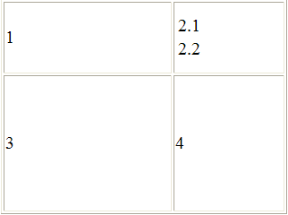
<TABLE BORDER="1" WIDTH="320" HEIGHT="240">  <TR>  <TD WIDTH="200" HEIGHT="80" VALIGN="TOP"> 1  </TD>  <TD WIDTH="120" HEIGHT="80">  <TABLE BORDER="0" WIDTH="120" HEIGHT="40">  <TR>  <TD ALIGN="RIGHT"> 2.1 </TD>  </TR>  <TR>  <TD> 2.2 </TD>  </TR>  </TABLE>  </TR>  <TR>  <TD ALIGN="CENTER" VALIGN="CENTER"> 3 </TD>  <TD ALIGN="RIGHT" VALIGN=”BOTTOM”> 4 </TD>  </TR>  </TABLE>  Explanation:  We now use the VALIGN and ALIGN attributes to align the content in each cell. | 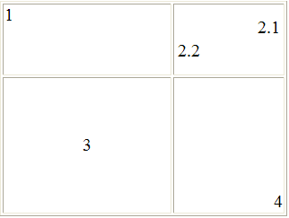

3. Amulet Widgets

3.1 Lab Setup

Now we will be dealing with HTML examples that are specific to the Amulet compiler and will not work completely on your web browser. To go through these examples in lab, use the following lab setup as described in the Amulet Startup Guide:

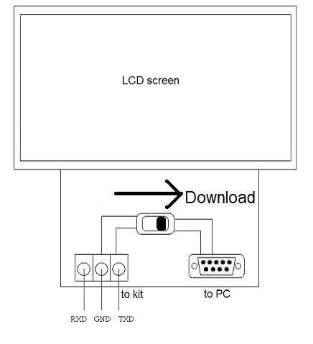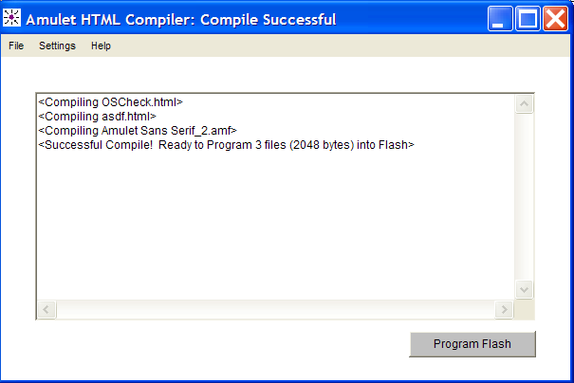

For the remaining examples, save a template HTML file as amulet2.html on your desktop. Once again, edit amulet2.html using Notepad or another text editor.

Copy and paste this code in amulet2.html after the text marked <!-- your content goes here -->  Explanation:  Here, we explain the example. | Compile and download amulet2.html. (See Amulet Startup Guide for instructions.) This is what you should see on the Amulet screen.
3.2 Introduction to Amulet Widgets

Amulet widgets are used to interact with the user, display data to the user, and to initiate the transfer of data to the R31JP.

There are two main types of widgets. Control widgets take input from the user via pushbuttons, sliders, and the like. View widgets display data from the R31JP or from its own memory via line plots, bar graphs, numeric fields, and the like. Control and view widgets may interact with each other or with the R31JP. The Amulet documentation (under Amulet Widgets) gives a name, picture, and description for each of the widgets.

To use an Amulet widget, first pick the table cell that you want your widget in. Then you can essentially cut and paste widget code into that cell. The only thing you need to do is to define certain properties of the widget (i.e. the size and look of a button, the name of a checkbox). For example,

Source Code | What you see…
<TABLE BORDER="1" WIDTH="320" HEIGHT="240">  <TR>  <TD WIDTH="200" HEIGHT="80" VALIGN="TOP"> 1  </TD>  <TD WIDTH="120" HEIGHT="80">  <APPLET CODE="FunctionButton.class"  WIDTH="120" HEIGHT="80" NAME="Button1">  <PARAM NAME="href" VALUE="Amulet:UART.byteOut(0x54)">  <PARAM NAME="fontSize" VALUE="3">  <PARAM NAME="fontStyle" VALUE="BOLD">  <PARAM NAME="label" VALUE="Send 0x54">  <PARAM NAME="buttonType" VALUE="SPRING-LOADED">  <PARAM NAME="onButtonPress" VALUE="DEPRESS">  </APPLET>  </TD>  </TR>  <TR>  <TD ALIGN="CENTER" VALIGN="CENTER"> 3 </TD>  <TD ALIGN="RIGHT"> 4 </TD>  </TR>  </TABLE>  Explanation:  Instead of our inner table from the previous example, we have an Amulet widget, the function button. Notice: 1) widgets don’t show up in your internet browser, 2) borders don’t show up in the LCD panel.  See below for details on the function button widget. | from a web browser:  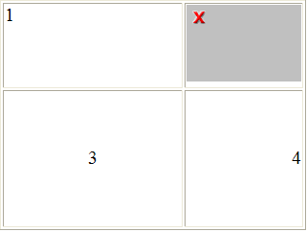  with similar code on your LCD screen:  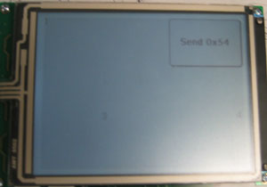

What did we just do …?

<APPLET¹ CODE="FunctionButton.class"² WIDTH="120" HEIGHT="80" NAME="Button1"³>
<PARAM NAME="href"⁴ VALUE="Amulet:UART.byteOut(0x54)">
<PARAM NAME="fontSize" VALUE="3">
<PARAM NAME="fontStyle" VALUE="BOLD">
<PARAM NAME="label" VALUE="Send 0x54">
<PARAM NAME="buttonType" VALUE="SPRING-LOADED">
<PARAM NAME="onButtonPress" VALUE="DEPRESS">⁵
</APPLET>
- The start and end tags for Amulet widgets are <APPLET> and </APPLET>, respectively.
- This tells the Amulet compiler what type of widget you want – function button, in this case.
- We set the attributes to widgets much like we do for tables. This is where we specify the dimensions and name of the widget.
- The parameter href tells the Amulet compiler what you want the Amulet module to do when the widget is activated. This is how you get the Amulet module to output data to your R31JP. In this example, using the Amulet:UART.byteOut(0x54) function, we tell the Amulet module to output 0x54 every time the button is pressed. For a complete list of functions, see the Amulet documentation under Appendix B: Function Matrix
- A full list and description of parameters is found in the Amulet documentation under Amulet Widgets.

4. Widget Communication

Amulet widgets may transfer data between each other or with an external processor.

4.1 Inter-Widget Communication

View widgets may display data taken from control widgets. This may be done in one of two ways:
- Directly – the view widget reads the current value of the control widget.
- Indirectly – the control widget saves its value into the Amulet InternalRAM, and the view widget reads from it. (The Amulet InternalRAM has 256 byte variables, 256 word (16-bit) variables, and 199 string variables, so space really is not an issue)

Source Code (Direct Inter-Widget Communication) | What you see…
<TABLE BORDER="1" WIDTH="320" HEIGHT="240">  <TR>  <TD WIDTH="320" HEIGHT="240">  <APPLET CODE="Field.class" WIDTH="100" HEIGHT="50"  NAME="display">  <PARAM NAME="href"  VALUE="Amulet:document.send.value()">  <PARAM NAME="fontSize" VALUE="5">  <PARAM NAME="fontStyle" VALUE="PLAIN">  <PARAM NAME="min" VALUE="0">  <PARAM NAME="max" VALUE="255">  <PARAM NAME="printf" VALUE="%5i">  <PARAM NAME="minFld" VALUE="0">  <PARAM NAME="maxFld" VALUE="255">  <PARAM NAME="updateRate" VALUE=".33,0.01">  </APPLET>  <APPLET CODE="Slider.class" WIDTH="150" HEIGHT="40"  NAME="send">  <PARAM NAME="href" VALUE="Amulet:NOP()">  <PARAM NAME="min" VALUE="0">  <PARAM NAME="max" VALUE="255">  <PARAM NAME="tickCount" VALUE="5">  <PARAM NAME="initialCondition" VALUE="0">  </APPLET>  </TD>  </TR>  </TABLE>  Explanation:  Here we have a view widget (numeric field) and a control widget (slider). View widgets can access the value of any control widget by using the command Amulet:document.name_of_control_widget.value(). Any object on the Amulet screen is within the Amulet “document.” | From a web browser:  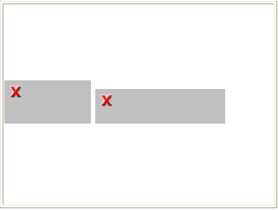  with similar code on your LCD:  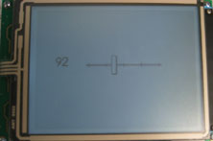
Source Code (Indirect Inter-Widget Communication) | What you see …
<TABLE BORDER="1" WIDTH="320" HEIGHT="240">  <TR>  <TD WIDTH="320" HEIGHT="240”>  <APPLET CODE="Field.class" WIDTH="100" HEIGHT="50"  NAME="display">  <PARAM NAME="href"  VALUE="Amulet:InternalRam.byte(0x06).value()">  . . . .  </APPLET>  <APPLET CODE="Slider.class" WIDTH="150" HEIGHT="40"  NAME="send">  <PARAM NAME="href"  VALUE="Amulet:InternalRam.byte(0x06).setValue()">  . . . .  </APPLET>  </TD>  </TR>  </TABLE>  Explanation:  The only changes to the previous code are the href commands. The slider stores its current value to the InternalRAM byte variable 0x06 every time it is changed by the user, and the numeric field reads from it. | Same as above.

  - Lab Setup for Widget/R31JP Communication

To transfer data between your R31JP and the Amulet module, you will have to use the following the following lab setup, as described in the Amulet Startup Guide:

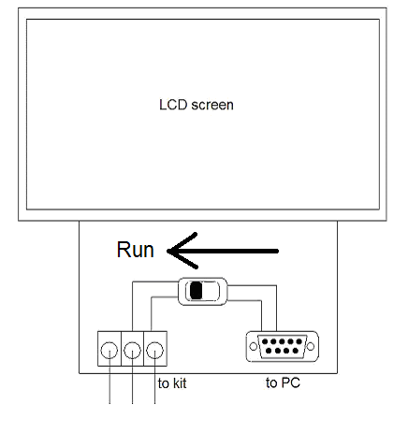
RXD
TXD
Your Kit

  - Serial Protocol

We already saw an example of a control widget passing data out the serial port and to the R31JP. In Section 3, our very first Amulet example used the href command, “Amulet.UART.byteOut(x).” This command is great, because the Amulet module sends out a raw byte without worrying about what happens to it. But what happens when we need a more complicated transaction?

We’ll focus on widget-initiated UART communication here. View widgets may want to display data taken directly from the R31JP (i.e. a “get” command), and control widgets may want to change values in the R31JP’s memory (i.e. a “set” command). A similar set of commands exists for R31JP-initiated communication, plus some extra commands, which you will see in the next section, under Graphic Primitives. For further information, see the Amulet documentation under UART Protocol.
Here are some examples of widget-initiated transactions:
Source Code | What you see on the LCD screen:
<TABLE BORDER=“1” WIDTH="320" HEIGHT="240">  <TR><TD WIDTH="320" HEIGHT="240">  <APPLET CODE="LinePlot.class" WIDTH="150"  HEIGHT="150" NAME="LinePlot1">  <PARAM NAME="href"  VALUE="Amulet:UART.byte(0x01).value()">  <PARAM NAME="yMin" VALUE="0">  <PARAM NAME="yMax" VALUE="255">  <PARAM NAME="xSamples" VALUE="30">  <PARAM NAME="lineWeight" VALUE="3">  <PARAM NAME="linePattern" VALUE="0">  <PARAM NAME="updateRate" VALUE=".05">  </APPLET>  </TD> <TR>  </TABLE>  Explanation:  This is a line graph, a type of view widget. It requests data from address byte 0x01 of the R31JP every 0.05 seconds, and displays it. | 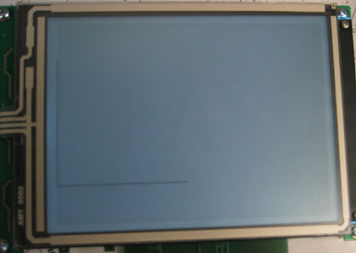
<TABLE BORDER="1" WIDTH="320" HEIGHT="240">  <TR>  <TD WIDTH="320" HEIGHT="240">  <APPLET CODE="Slider.class" WIDTH="50"  HEIGHT="200"  NAME="slider1">  <PARAM NAME="href"  VALUE="Amulet:UART.byte(0x02).setValue()">  <PARAM NAME="min" VALUE="0">  <PARAM NAME="max" VALUE="255">  <PARAM NAME="tickCount" VALUE="5">  <PARAM NAME="initialCondition" VALUE="0">  <PARAM NAME="orientation" VALUE="VERTICAL">  </APPLET>  </TD>  </TR>  </TABLE>  Explanation:  This is a slider, a type of control widget. Every time the user changes the value of the slider, it asks the R31JP to set address 0x02 to the value selected by the user. | 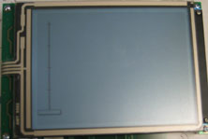

Excellent, but what does the Amulet module output when it sends a get or set command? What does the R31JP see?

First, the widget sends a “wakeup” byte out the serial port. The value of the wakeup byte depends on the command. Here are the only commands you should need:

Widget href command | Translation | Sent by | Wakeup byte
Amulet:UART.byte(x).value() | Get byte variable | View widget | 0xD0
Amulet:UART.word(x).value() | Get word variable | View widget | 0xD1
Amulet:UART.bytes(x).value() | Get byte variable array | View widget | 0xDD
Amulet:UART.words(x).value() | Get word variable array | View widget | 0xDE
Amulet:UART.byte(x).setValue(y) | Set byte variable | Control widget | 0xD5
Amulet:UART.word(x).setValue(y) | Set word variable | Control widget | 0xD6
After the wakeup call, the widget will ask the external processor for a specific variable address. The Amulet module uses an ASCII protocol. Therefore, if the Amulet wants data from variable 0x02, it will send a ‘0’ (0x30) followed by a ‘2’ (0x32). To complete its “set byte/word” command, control widgets will then send another byte (or word).

Here are some examples:

Href Command | Amulet Output
Amulet:UART.byte(0x06).value() | 0xD0 0x31 0x36
Amulet:UART.word(0x51).value() | 0xD1 0x35 0x31
Amulet:UART.word(0x20).setValue(0x1234) | 0xD6 0x32 0x30 0x31 0x32 0x33 0x34

You will have to process the input, one byte at a time, and respond appropriately. When you are ready to respond, send a “wakeup” call back to the Amulet. This wakeup call is the same as the original wakeup call, except the 0xD- becomes a 0xE-. Then, for a control widget, mimic the original command minus the 0xD- wakeup byte. For a view widget, send back the variable address and the data at that address.

Summary: You can initiate a transaction with the R31JP when a user activates a control widget by giving the widget a href command. This command will be called every time the user activates this widget. Junk will come pouring out of the Amulet’s TXD line, which you will interpret using the 16450 and appropriate R31JP assembly. If the Amulet expects an answer, you must send information back through the 16450 and the Amulet’s RXD line. All transactions must be done using Amulet’s very specific protocol.

Here is a sample transaction:

R31JP address 0x01 = 0x52
R31JP address 0x02 = 0x00

Amulet | Direction | R31JP
0xD0 0x30 0x31  ‘0’ ‘1’ | >>>
 | <<< | 0xE0 0x30 0x31 0x35 0x32  ‘0’ ‘1’ ‘5’ ‘2’
0xD0 0x30 0x32  ‘0’ ‘2’ | >>>
 | <<< | 0xE0 0x30 0x32 0x30 0x30  ‘0’ ‘2’ ‘0’ ‘0’
0xD5 0x30 0x31 0x39 0x39  ‘0’ ‘1’ ‘9’ ‘9’ | >>>
 | <<< | 0xE5 0x30 0x31 0x39 0x39  ‘0’ ‘1’ ‘9’ ‘9’

R31JP address 0x01 = 0x99
R31JP address 0x02 = 0x00

5. Graphic Primitives

So you don’t want to write HTML…? You can still use your Amulet module as an Etch a Sketch! Using your R31JP, you can draw simple shapes: lines, filled and unfilled rectangles, and dots.

You can draw shapes through anything already on the screen, including previously loaded text and widgets! This isn’t probably what you want to do, so we recommend you first download the blank template to the Amulet module. When you want to start over, pressing reset will give you a clean slate.

Like before, when we want to tell the Amulet to draw something, we send it a wakeup byte:

Command | Wakeup Byte
Draw line | 0xD9
Draw unfilled rectangle | 0xDA
Draw filled rectangle | 0xDB
Draw pixel | 0xDC

Then we have to specify the x and y coordinates of the shape. Remember that the LCD is 320 by 240 pixels (0x140h by 0xF0h), so you should only ask for x, y coordinates between (0, 0) and (320, 240). For lines, we specify the coordinates of both the start and end points. For rectangles, we specify the top left corner, the width, and the height (so we can’t have slanted rectangles).

Finally, we tell the Amulet module details of our shape. We must specify the pattern of the line or filled rectangle and the thickness (number of pixels) of our lines. Each number between 0 and 15 represents a different pattern. Look in the Amulet documentation under Graphic Primitives for all the different patterns. If you don’t need to be fancy, then it is enough to know that pure black is 0, gray is 1, and pure white is 15.

Summary: You can draw lines, rectangles, and dots (“graphic primitives”) on the Amulet LCD screen. To do so, you must send a stream of information to the Amulet module, starting with the wakeup byte. This stream must follow the Amulet protocol for graphic primitives. The Amulet may send junk back at the R31JP to let you know that it has received your command, but you may ignore it. Graphic primitives are an example of an R31JP-initiated transaction.

Here are some examples, taken directly from the Amulet documentation:
1) To draw a line from (0x05,0x07) to (0x65,0x67), line weight of 4 and using line pattern 1(gray), the following would be sent to the Amulet:
0xD9,0x30,0x30,0x30,0x35,0x30,0x30,0x30,0x37,0x30,0x30,0x36,0x35,0x30,0x30,0x36,0x37,0x31,0x34
| {-----------------} {-----------------} {-----------------} {-----------------} | |
| pnt 1, x pnt 1, y pnt 2, x pnt 2, y line |
draw (0x05) (0x07) (0x65) (0x67) pattern |
line line
opcode weight
(0x04)
2) To draw a rectangle that is 0x10C pixels wide, 0x82 pixels tall, has a top left point at (0x0A,0x05), a line weight of 2 and using line pattern 0 (black), the following would be sent to the Amulet:
0xDA,0x30,0x30,0x30,0x41,0x30,0x30,0x30,0x35,0x30,0x31,0x30,0x43,0x30,0x30,0x38,0x32,0x30,0x32
| {-----------------} {-----------------} {-----------------} {-----------------} | |
| pnt 1, x pnt 1, y delta x delta y line |
draw (0x0A) (0x05) (0x10C) (0x82) pattern |
rectangle line
opcode weight
(0x02)
3) To draw a filled rectangle that is 0x140 pixels wide, 0xF0 pixels tall, has a topleft point at (0x00,0x00) and using fill pattern 15 (which equals to 0x0F in hex)(white), the following would be sent to the Amulet:
0xDB,0x30,0x30,0x30,0x30,0x30,0x30,0x30,0x30,0x30,0x31,0x34,0x30,0x30,0x30,0x46,0x30,0x46,0x31
| {-----------------} {-----------------} {-----------------} {-----------------} | |
| pnt 1, x pnt 1, y delta x delta y fill |
draw (0x00) (0x00) (0x140) (0xF0) pattern |
fill (0x0F) line
rectangle weight
opcode (N/A)
4) To draw a single pixel at point (0x32,0x54) and using fill pattern 0(black) , the following would be sent to the Amulet:
0xDC,0x30,0x30,0x33,0x32,0x30,0x30,0x35,0x34,0x30,0x31
| {-----------------} {-----------------} | |
| pnt 1, x pnt 1, y fill |
draw (0x32) (0x54) pattern |
pixel (0x00) line
opcode weight
(0x01)

5. A final example – Putting it all together

Let’s create a user interface for a super-smart microwave, the AWESOM-O uWAVE 8000. The microwave only needs to know: 1) a temperature setting between 1 and 10, and 2) a duration setting between 1 and 50.

Source Code | What you see…
First, design the layout without widgets:  <TABLE BORDER="1" WIDTH="320" HEIGHT="240">  <TR>  <TD HEIGHT="60" COLSPAN="3" ALIGN="center">  <b>THE AWESOM-O uWAVE 8000</b></TD>  </TR>  <TR>  <TD WIDTH="106" HEIGHT="50" ALIGN="center">  <font size="2"> Temperature Setting</font>  </TD>  <TD WIDTH="107" ALIGN="center">  <font size="2"> Duration Setting</font></TD>  <TD WIDTH="107"></TD>  </TR>  <TR>  <TD ALIGN="center"> temp slider </TD>  <TD ALIGN="center"> dur slider </TD>  <TD ALIGN="right" VALIGN="bottom">  done<br>button</TD>  <TR>  </TABLE> | from a web browser:  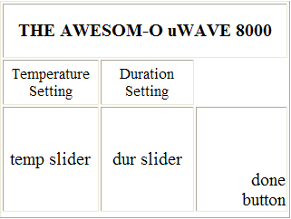
Now add widget code:  <TABLE BORDER="1" WIDTH="320" HEIGHT="240">  <TR>  <TD HEIGHT="60" COLSPAN="3" ALIGN="center">  <b>THE AWESOM-O uWAVE 8000</b></TD>  </TR>  <TR>  <TD WIDTH="106" HEIGHT="50" ALIGN="center">  <font size="2"> Temperature Setting</font></TD>  <TD WIDTH="107" ALIGN="center">  <font size="2"> Duration Setting</font></TD>  <TD WIDTH="107"></TD>  </TR>  <TR>  <TD ALIGN="center">  <APPLET CODE="Slider.class" WIDTH="20" HEIGHT="100"  NAME="tempSlider">  <PARAM NAME="href"  VALUE="Amulet:InternalRAM.byte(0x01).setValue()">  <PARAM NAME="min" VALUE="1">  <PARAM NAME="max" VALUE="10">  <PARAM NAME="tickCount" VALUE="10">  <PARAM NAME="initialCondition" VALUE="1">  <PARAM NAME="orientation" VALUE="VERTICAL">  </APPLET>  </TD>  <TD ALIGN="center">  <APPLET CODE="Slider.class" WIDTH="20" HEIGHT="100"  NAME="durSlider">  <PARAM NAME="href"  VALUE="Amulet:InternalRam.byte(0x02).setValue()">  <PARAM NAME="min" VALUE="1">  <PARAM NAME="max" VALUE="50">  <PARAM NAME="tickCount" VALUE="50">  <PARAM NAME="initialCondition" VALUE="1">  <PARAM NAME="orientation" VALUE="VERTICAL">  </APPLET>  </TD>  <TD ALIGN="right" VALIGN="bottom">  <APPLET CODE="FunctionButton.class" WIDTH="60"  HEIGHT="40" NAME="start">  <PARAM NAME="href" VALUE=  "Amulet:UART.byte(0x01).value(Amulet:InternalRam.byte(0x01),  Amulet:UART.byte(0x02).value(Amulet:InternalRam.byte(0x02)">  <PARAM NAME="fontSize" VALUE="3">  <PARAM NAME="fontStyle" VALUE="BOLD">  <PARAM NAME="label" VALUE="START">  <PARAM NAME="buttonType" VALUE="SPRING-LOADED">  <PARAM NAME="onButtonPress" VALUE="DEPRESS">  </APPLET>  </TD>  <TR>  </TABLE>  Explanation: see below | from a web browser:  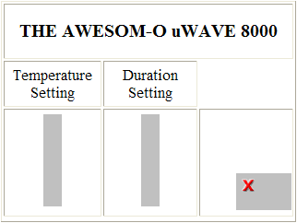  with similar code on your LCD screen:  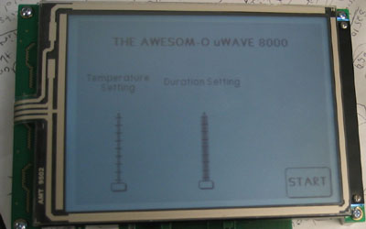

Notes:
- We use two sliders and a function button.
- When activated, the sliders save their intrinsic value in bytes 0x01 and 0x02 of the InternalRAM.
- When pressed, the function button sends the value of both sliders to the R31JP, the first to be stored at address 0x01, the second at address 0x02 of the R31JP. To transmit this command, the Amulet module will output: “0xD0 0x30 0x31 _temperature_slider_value_ 0xD0 0x30 0x32 _duration_slider_value_.” Notice the syntax of sending two commands in a single href.
- You cannot directly access the slider values from the function button, because the function button is a control widget, not a view widget! Please take note of what commands are available to view widgets, and what commands are available to control widgets.

