Amulet Startup Guide

1. Design your LCD panel, then code and compile it

The Amulet module specifies appearance using basic HTML. Please see the HTML tutorial if you have limited experience with HTML. For experts, skip to the description of Amulet widgets (part 3 of the HTML tutorial). Amulet provides a library of widgets for user interaction: pushbuttons, sliders, etc.

On the desktop of the PC, there should be an Amulet folder with a template HTML document. Open template.html using a text editor (Emacs, Notepad, etc.) Use this template for all Amulet HTML programs. You will have fewer unexpected compile errors this way.

The template you will be using looks something like the following:

<!DOCTYPE HTML PUBLIC "-//W3C//DTD HTML 3.2//EN">
<!--last modified on Monday, December 11, 2000 08:01 AM -->
<HTML>
<HEAD>
<META HTTP-EQUIV="Content-Type" CONTENT="text/html;CHARSET=iso-8859-1">
<META NAME="Amulet" Content="baud=9600">
<TITLE>untitled</TITLE>
</HEAD>

<BODY>
<P>
<TABLE BORDER="0" CELLPADDING="0" CELLSPACING="0" WIDTH="320" HEIGHT="240">
<TR>
<TD WIDTH="320" HEIGHT="240">
<P><!-- your content goes here -->
</TD>
</TR>
</TABLE>
</BODY>
</HTML>

Notice the highlighted line of the program. This sets the baud rate of the Amulet module to 9600. If you leave this line out of your code, the Amulet module will default to a baud rate of 115200.

Once you are ready to compile your code, open the Amulet Compiler at Start->Programs->Amulet->HTMLCompiler. Then open your HTML document by going to File->Open and selecting your file. If the compile is successful, you should see something like this:

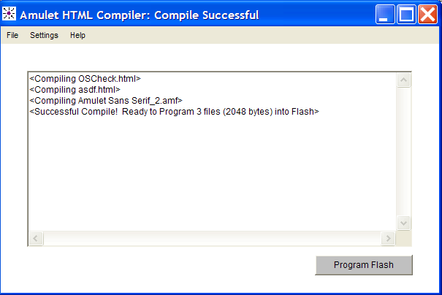
2. Download your code onto the Amulet board

Shown below is a cartoon of what you will see in lab. A switch on the board switches the Amulet module between download mode (labeled “PC”) and run mode (labeled “Kit”). Never connect or disconnect the serial cable from the Amulet board when the serial line is active. The serial line is active when the switch is flipped to the right (towards “PC”) and the Amulet board is powered on.

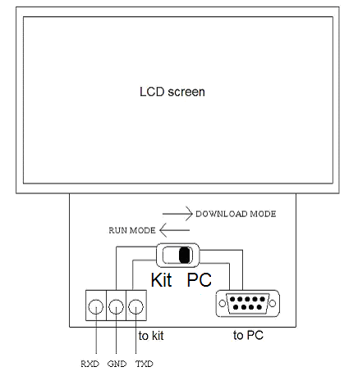

Connect the Amulet module to your PC using the serial cable you normally use for the R31JP. Flip the switch to the right.

From the Amulet HTMLCompiler, go to Settings->RS232. A box like the one below should pop up. Set the settings like the following:

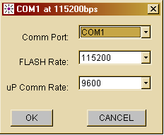

What do these lines mean?

- Comm Port: You are specifying that you want to send data through the main serial port.
- FLASH Rate: This is how fast the PC sends your program to the Amulet module. A FLASH rate of 115200 is hardwired on the Amulet board, so you will never have a reason to change this line. Please note that the FLASH rate is independent of the baud rate of your program (which should be 9600).
- uP Comm Rate: The Amulet compiler must be able to tell the Amulet module that it has a new program to transfer. To do this, the Amulet compiler must know the baud rate of the last program you downloaded, which should be 9600. However, if you download any code that is not running at 9600, the next time you download a program, your uP Comm Rate must reflect the baud rate of the last program you downloaded. (Note that some errors in your code may not be detected by the Amulet compiler, and may cause your program to default to a baud rate of 115200. If this is the case, you must change the uP Comm Rate to 115200 the next time you want to download a program.) If your uP Comm Rate is incorrect, you will get a timeout error when you try to program the Amulet.

As you can see from the screen shot on the first page, after a successful compile, a “Program Flash” button comes up. Hit the button to begin programming the Amulet. Once complete, the display you designed should immediately pop up.

Connect the serial cable back to the R31JP as normal. Make sure the Amulet’s serial line is not active when you do this! You will not lose any of your downloaded code if you unplug the Amulet module. Flip the switch on the Amulet board to the left. The wires labeled “to kit” on the diagram above are now active. These wires expect TTL voltage levels, so do not do anything to damage the Amulet module! To be safe, power off the Amulet board until you are ready to use it with the R31JP.

3. Wire a 16C450

The Amulet module communicates serially using a single receive and a single transmit line. RXD is the Amulet input (R31JP output) and TXD is the Amulet output (R31JP input). As you know, the R31JP uses pins D0-D7 to receive and transmit data. In other words, the R31JP needs data in a parallel format.

Wire a 16C450, which will perform the necessary serial-to-parallel and parallel-to-serial operations. In order for proper communication to occur, the 16C450 must run at the same speed as the Amulet module. You should be able to use the 10MHz crystal to generate the necessary baud rate of 9600. The 16C450 datasheet will tell you how to connect the crystal. You do not need an additional buffer between the crystal and the 16C450.

Please read the datasheet for further details.

You are now set up to use the Amulet module with your R31JP.

Good luck!

